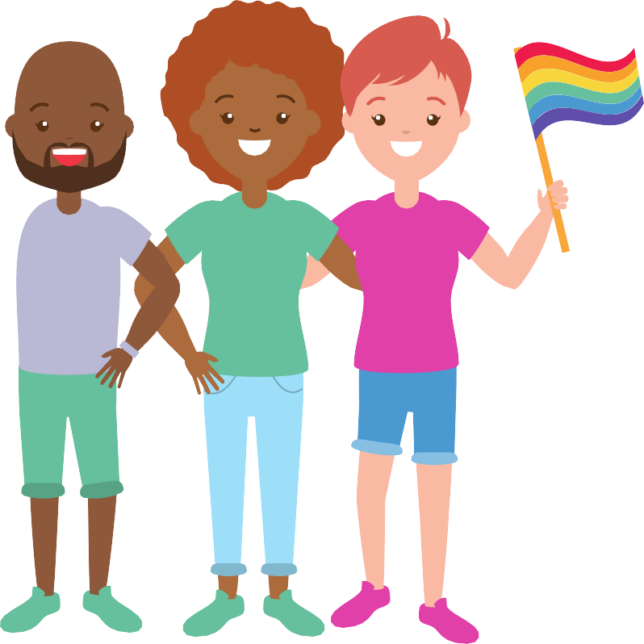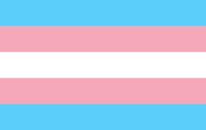ME AND
MY
DOCTOR
UNDERSTANDING YOUR HEALTHCARE RIGHTS AS AN LGBTIQA+ YOUNG PERSON

BACKGROUND

Going to the doctor as a young person can be intimidating, especially as an LGBTIQA+ young person. Visiting the doctor shouldn’t be scary, and it’s important now more than ever to look after yourself and your health in this period of COVID- 19 recovery.

When we talked to young LGBTIQA+ people in WA one their biggest concerns during COVID-19 was having to see new health workers. These concerns are totally normal - especially if it's your first time seeking healthcare. On top of this, the real or perceived discrimination against LGTBIQA+ people within the healthcare system can make it really difficult to comfortably navigate the system and get treatments that are right for you. No matter who you see, there are certain rights and responsibilities you have with all healthcare you receive to make sure you’re getting the best treatment possible.

WHAT ARE MY HEALTHCARE RIGHTS AS A YOUNG LGBTIQA+ PERSON?
The Australian Charter of Healthcare Rights is a big list of rules that outlines what your rights and responsibilities are when receiving healthcare. This healthcare can be with any healthcare professional - your GP, a psychologist, a nurse, a doctor at a hospital, etc. But what do these mean for young LGBTIQA+ people accessing health services?

There are seven main rights within the charter. These are rights to:

Access Safety Respect
Partnership Information
Privacy

Give feedback

WHAT'S IN THIS GUIDE?
This guide outlines your rights and responsibilities under these seven areas and how they apply to an LGBTIQA+ context. Being familiar with these will help you feel more confident when seeing a healthcare professional and give you the tools and knowledge to navigate the healthcare system like a pro! LGBTIQA+ inclusive healthcare should be standard across all services, however sometimes healthcare workers don’t understand or know enough about LGBTIQA+ experiences. In situations like this, knowing your rights will help you become better at self advocating - meaning you’ll be better at shaping the healthcare system to suit you and your needs when they don’t automatically do it for you. Equally, while self-advocating is a useful skill to know, we want to make it clear that the burden of providing appropriate care should always be with healthcare workers.

Additionally, this guide should also provide context for health workers to apply healthcare rights to an LGBTIQA+ context to better serve the community. Specific resources on how to work towards a more inclusive practice are detailed at the end of this guide. This guide should not be considered legal advice.

The Youth Affairs Council of Western Australia

MY HEALTHCARE RIGHTS – AN LGBTIQA+ PERSPECTIVE

ACCESS
"I have a right to healthcare services and treatment that meets
my needs"

LGBTIQA+ people have the same health concerns as anyone else, but there are sometimes concerns you might have that are specific to your sex, sexuality or gender identity. These might include things specific to trans and gender-diverse (TGD) people such as getting hormone replacement therapy (HRT), care specific to the needs of intersex people, as well as sexual health concerns. As a patient, you have a right to receive care that meets these needs. You have a right to be able to access inclusive, affirming and knowledgeable health workers that will give you the same level of care as any other patient that walks through their doors.

Making sure your healthcare provider knows how to treat you is super important. It can be frustrating and draining to deal with healthcare providers that don’t know how to give you LGBTIQA+ specific care, and is also why so many young people are too afraid to see a doctor.

On top of that, LGBTIQA+ people often face barriers when accessing healthcare due to worrying that they may be judged or discriminated against, which can make the whole experience extremely uncomfortable and scary. As such, it’s important that healthcare services you access recognise the unique needs of the LGBTIQA+ community and are able to respond to them. If you don’t think your healthcare provider has the knowledge to serve your needs, you have a right to be directed to healthcare providers that can meet those needs.

Example: Lyla is a young person who is trans and is wanting to start HRT. Her local GP doesn’t have enough knowledge to appropriately help her with treatment, but is able to direct her to endocrinologist services that are more equipped to help her and provide the right advice.

The Youth Affairs Council of Western Australia

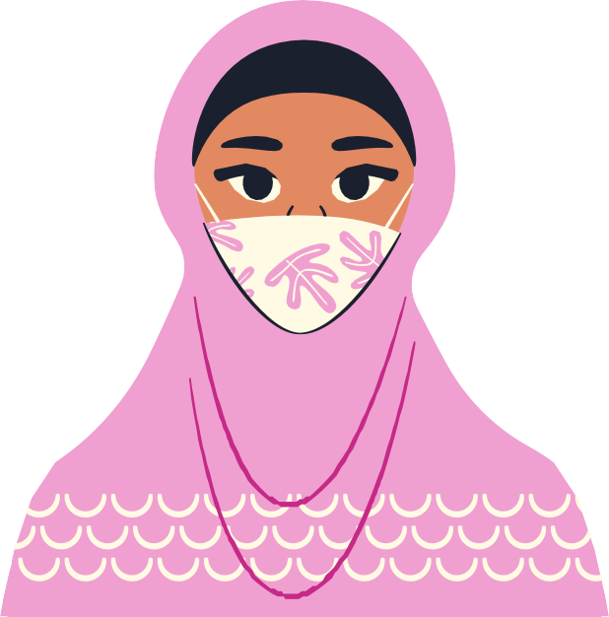

SAFETY
"I have a right to receive safe and high quality health care that
meets national standards"

Good quality healthcare is for everyone - being LGBTIQA+ should not affect your healthcare experience.

No matter who they see, healthcare workers have to ensure that all people enjoy safe, quality healthcare at a consistent standard nationwide. Part of meeting these standards is recognising and respecting the diversity of all patients, including LGBTIQA+ young people. Healthcare workers should also be able to communicate well with you, which requires LGBTIQA+ health literacy - meaning that they should be aware of LGBTIQA+ language and also health needs specific to the community.

LGBTIQA+ health literacy is essential for providers to be able to provide safe and effective care for LGBTIQA+ young people. Safety in healthcare is incredibly important for LGBTIQA+ people - discrimination and systems that don’t understand the experiences of the community have led to some unique health problems that health care providers should know and understand. You should feel safe with your doctor, and health services should never discriminate against you because of your identity.

Example: Mai is a young pansexual woman in a relationship with another woman. Mai’s GP assumes she is in a heterosexual relationship and provides her with sexual health information not relevant to her situation. Mai has to tell her GP that she is actually in a queer relationship and that both her and her partner are cisgender women, and as such information on some contraceptives and pregnancy are not relevant to her at this time, and that she would instead like sexual health information that is relevant to her relationship. The assumption from her GP wasted much of Mai’s appointment time and was draining for her to have to correct them - she deserves to see a GP that does not assume her sexuality and will give her the right treatment.

The Youth Affairs Council of Western Australia

RESPECT
"Be treated as an individual, and with dignity and respect" "Have my culture, identity, beliefs and choices recognised and
respected”

No one deserves to be discriminated against or treated with disrespect. You have a right to receive care that respects you as an LGBTIQA+ person and your identity as an LGBTIQA+ person should be respected by your healthcare provider at all times. There are certain state and national laws as well as healthcare charters that prevent you from being discriminated against on the basis of your diversity, sexuality, or gender identity that provide a framework for services to operate by.

You should never have to just ‘put up’ with being disrespected - discrimination is never
acceptable.

Being treated with dignity and respect as an LGBTIQA+ person looks like:

Your identity, pronouns and name are recognised and respected;

Your identity and relationships aren’t challenged, belittled or questioned; and

The type of sex you have, the way you have sex and who you have sex with is respected.

If you feel like you have experienced discrimination or do not feel respected by your healthcare provider, you have a right to tell them this or find other service providers.

Example: Alex is a young non-binary person who has been admitted to hospital. On their admission forms, they notice male and female are the only gender options. They ask the receptionist what they should do if they don’t identify as either of the genders listed, but the receptionist rudely tells them to just pick one. Alex feels extremely upset by the experience and doesn’t feel as though their identity was respected in the exchange.

The Youth Affairs Council of Western Australia

PARTNERSHIP
"I have a right to receive safe and high quality health care that
meets national standards"

No one knows you better than you. In order for healthcare workers to help you to the best of their ability, it’s important that you’re on the same page as them when it comes to making decisions. You have both a right and responsibility to talk with your healthcare provider about your care and treatment - you have a right to be spoken to with honesty, and you have a responsibility to be informed about your treatment and tell your doctor what you want. This means asking questions when you are unsure about something, and working with your healthcare provider to find what works best for you, which will often involve making decisions based on the information and advice they give you.
Decisions you make should only be made with enough information provided from your healthcare professional - this way you can provide ‘informed consent’. If you are under 18, it will depend on your healthcare provider whether they consider you able to provide informed consent without needing the help of an adult such as a parent or guardian.

But what is ‘informed consent’?
‘Informed consent’ basically means that any decision you make is based on information you’ve received from a health professional that you have considered and thought about before reaching a conclusion. Generally, you’re able to give informed consent if you are 18 and over, but there is no formal framework for younger people. In WA, anyone younger than 18 is considered on a case- by-case basis for informed consent, otherwise they usually need an adult to consent for them.
Understanding consent is really important, especially if you are under 18. While you can see a doctor by yourself at any age, your doctor will assess on a case by case basis whether you’re able to provide this consent - whether that be as an adult, as a mature minor, or through a parent or guardian. Part of partnership is talking to your doctor about issues such as consent and privacy to make sure you understand how and why decisions about your health are made.

Example: Mike discloses that he is having sex with men and wants to talk with his doctor about his options to prevent STIs. The doctor tells him to use condoms and only have sex with one partner. In this case the doctor should have given Mike all of his options and worked with him to find out what works best for Mike.

The Youth Affairs Council of Western Australia

INFORMATION
"Clear information about my condition, the possible benefits and risks of different tests and treatments, so I can give my informed
consent"
"Receive information about services, waiting times and costs" "Be given assistance, when I need it, to help me to understand and use
health information" "Request access to my health information"

"Be told if something has gone wrong during my health care, how it happened, how it may
affect me and what is being done to make care safe

You have the right to all of the above, meaning your healthcare provider should give you health information should you ask for it. Sometimes it’s your first time accessing healthcare by yourself, but no one expects you to know everything! Your doctor is a trained professional and won’t expect you to have the same amount of knowledge on treatments and procedures as they do, so they should always be willing to explain things to you no matter what the question. They should be informed, approachable, and happy to answer anything regardless of how big or small.

These may include questions around the risks and benefits of certain treatments, what certain terms might mean, requesting access to your health information, and any other questions that will help you feel informed and prepared. Any health information you want to access can generally be
found online in My Health Record, which you can manage yourself once you turn 14. If your doctor doesn’t have enough knowledge to fully inform you about a treatment (i.e. starting HRT or PrEP) they should refer you to a service that will be able to give you accurate information so that you can give informed consent to treatment. You can’t give informed consent if you are still unsure or feel you don't have enough information - so ask, ask, ask!

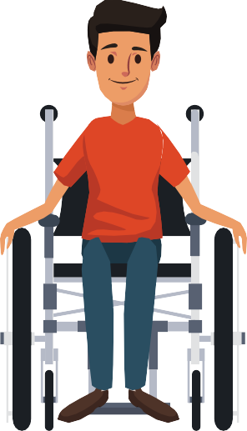

Example: Malik is a young person with an intersex variation. He wants to know how a particular medication will interact with his intersex variation but his doctor does not know. His doctor doesn’t really know how it will affect Malik and can’t provide him with appropriate health information. Because of this, Malik asks to be referred to another health professional that can give him the right information so that he is informed enough to consent to this new medication.

The Youth Affairs Council of Western Australia

PRIVACY
"Have my personal privacy respected" "Have information about me and my health kept secure and
confidential"

When it comes to your health, it's understandable that you will want your privacy respected. You have the right to privacy of your personal information when accessing health services. As an LGBTIQA+ young person, this is especially important as you may want your personal information - such as sexuality or gender identity - to be kept private, particularly if you aren’t out to your family and friends just yet. Privacy not only includes private doctors appointments - it includes privacy of your health information. Once you turn 14, you are able to manage your health information in My Health Record and your parents and guardians will be unable to access this information without your consent.

Any information you share with a healthcare provider should be kept confidential - meaning it will remain private between you and them. Confidentiality can be a big concern for young people - especially if you're sharing particularly sensitive information such as details about your
mental or sexual health. In the same way you are entitled to privacy, your health information should remain confidential unless you consent to this information being shared. You are also able to choose what information your doctor discloses on your health record, and request that certain information on your sexuality and/or gender not be recorded.

But there are times when your information may be disclosed to other people. As a general rule, this is usually when:

You consent to your information being shared, or

You are at risk of harm to yourself, or there's a risk of someone else harming you, or

You are at risk of harming someone else

There are other reasons why your information may be disclosed, which you can check out in some of the links in this guide’s resources section. If you’re under 18, it's important to discuss with the healthcare worker you’re seeing what will and will not be kept confidential. If you are asked a question you can ask the doctor whether they will tell anyone your answer and they need to answer honestly.

Example: Jack goes to a doctor to start a new skin care treatment. Jack has to attend a follow up appointment with his parent and in that appointment the doctor starts telling his parents about other things, including him disclosing he’s had sex with men to his parent. The doctor did not have Jack’s permission to disclose this to his parents and the doctor is breaching their responsibility to provide confidentiality.

The Youth Affairs Council of Western Australia

GIVE FEEDBACK
"Provide feedback or make a complaint without it affecting
the way that I am treated" "Have my concerns addressed in a transparent and timely way"
"Share my experience and participate to improve the quality
of care and health services"

It is important to know that you have the right to tell your healthcare provider how you feel about their service - good or bad. Though we hope providers are inclusive, it is not always the case. By providing feedback about your experience as an LGBTIQA+ young person, your opinion will be valued and help create a more inclusive environment for others!

No matter what, all healthcare workers should respect your healthcare rights. If you ever feel that the healthcare worker you’re seeing has not respected these rights, such as:

The service feels inaccessible;

You don’t feel respected by the service/ healthcare worker;

You feel like you can’t communicate well with your healthcare provider;

The information your provider gives you is too little, too hard to understand or they refuse to explain information;
Your privacy and confidentiality is not respected, or;

You generally feel uncomfortable with the healthcare worker you're seeing

...then you can and should provide feedback about how you feel. If you experience discrimination, you should be able to give feedback and not fear how you will be treated in the future. If you want to make a complaint, there's a few different steps you can take. Sometimes simply talking to your doctor can resolve the issue, whereas other times you may need to make a formal complaint. If this happens, it's best to talk to the service provider directly first. You can also submit a complaint to the Health and Disability Complaints Office (HaDSCO) or a number of other services that can be found in the resources section of this guide.

As a young person, there is always a fear that you may not be listened to or believed. Your feedback should always be valued, so never be afraid to speak up.

Example: Priyanka is asexual and goes to her GP to ask for a prescription to a contraceptive pill to help with her acne problems and heavy periods. Her doctor asks if she is sexually active and she says that she is not, and that she is asexual and is not really interested in sex. Her doctor doesn’t fully understand, and keeps saying the pill will be useful for ‘when’ she decides to be sexually active. Priyanka feels pretty invalidated by the experience, and provides feedback to her doctor that they should have a look at some resources about asexuality so that they can better serve the needs of asexual patients like herself.

The Youth Affairs Council of Western Australia

LGBTIQA+ HEALTHCARE RESOURCES

FOR LGBTIQA+ YOUNG PEOPLE

Want to know more information about your rights? We’ve collected a bunch of helpful resources to help you navigate the healthcare system as a young LGBTIQA+ person. These resources are aimed at increasing your health knowledge, helping you to self-advocate, finding appropriate services in WA, as well as some other bits and pieces of useful health-related advice!

Australian Commission on Safety and Quality in Health Care - Australian Charter of Healthcare Rights
The Charter provides the basis for this guide - check out the Commission's website to view the Charter, related resources, as well as a list of organisations to contact if you have any questions about the Charter or your healthcare rights in general
https://www.safetyandquality.gov. au/consumers/working-your- healthcare-provider/australian- charter-healthcare-rights

Youth Law Australia - Your Rights at the Doctor

Transhub - Health and Gender Affirmation in NSW

Consumers of Mental Health WA - Self-Advocacy Tips: Advocating for Yourself and Finding Your assertive Voice
An easy to understand guide about your legal rights at the doctor

This resource contains some great self-advocacy tips as well as safe binding techniques that are still useful post COVID-19

Breaks down self-advocacy into a list of starting points that will help you feel prepared, no matter the situation
https://yla.org.au/wa/topics/health
-love-and-sex/your-rights-at-the- doctor/

https://www.transhub.org.au/covi d19

http://static1.squarespace.com/st atic/5ee88174e9df4a4140e3e19a
/5ee883f8a4c5522c10234320/5e e883b7a4c5522c1023231a/15922
96375609/Self-Advocacy-Tips.pdf? fbclid=IwAR2EdmAIItKWHuI987Td ZuRniwU_NRT- 1tfX4cx70r3Kh0vchQowgbMGJMA

Peter Mac Cancer Foundation
- Being Ok… Being You: A Guide for Young People Who Identify as LGBTIQ+ and Have Cancer
Contains self-advocacy tips, your health rights, as well as some experiences of other young LGBTIQ+ young people with cancer
https://www.petermac.org/sites/d efault/files/page/downloads/LGBTI
_Book%20FINAL.pdf

Reimagine Today - LGBTIQ+ Communities Hub
A guide with tips and personal experiences of those engaging with the National Disability Insurance Scheme (NDIS) as an LGBTQIA+ person
http://www.reimagine.today/lgbtiq
-communities-hub/

The Youth Affairs Council of Western Australia

Justice Connect - How to Change Your Gender Status on Formal Documents
State-specific guide on how to change your gender status on a number of different formal documents
https://justiceconnect.org.au/reso urces/how-to-update-your- gender-on-formal-documents-wa/

TransHub - My Health Trans specific health Information and
resources
https://www.transhub.org.au/healt h

Raising Children - Teenage health care: your child's rights and responsibilities

Legal Aid WA - Your Rights: LGBTIQA+
A full guide to many of your healthcare rights as a young person in Australia

Legal Aid WA, in collaboration with the Youth Pride Network, have some fantastic factsheets on understanding
https://raisingchildren.net.au/pre- teens/mental-health-physical- health/health-care/teen-health- care
https://lavenderhealth.org/consu mers/self-advocacy/

your rights as an LGBTQIA+ young
person in WA
M Clinic - Me & My GP | A handy printout for MSM (men who have sex with men) to ensure you get the right STI tests from your doctor | https://waaids.com/media/k2/atta chments/Working-With-Your-GP- for-Sexual-Health-update- 20181002-5.pdf
The YEP Project - Resources | LGBTQIA+ inclusive sexual health resources | https://theyepproject.org.au/reso urces/
Health Consumers' Council - Self-Advocacy Resources | Clear, practical advice on how to advocate, including a guide on giving feedback | https://www.hconc.org.au/consum er/being-involved-in-your-own- health/self-advocacy-resources/
M Clinic - Finding a Health Professional | A list of gay, bi, and trans friendly GPs in WA | https://www.mclinic.org.au/finding  -health-professional
DocList, The List - Doctors and | A list of health services recommended | http://www.doclist.com.au/thelist
Mental Health Professionals | by lesbian and bi+ women in WA and
Recommended by Lesbian | around Australia
and Bisexual Women
The YEP Project - Youth- | Youth friendly sexual health services in | https://theyepproject.org.au/reso
Friendly Sexual Health | WA - look out for the services with an | urces/referral-resource-2020/
Services in the Perth Metro | LGBT+ and trans flag for LGBTIQA+
Area | inclusive services
Transfolk of WA - Trans Friendly Services List | If you’re looking for a trans friendly health service in WA, shoot Transfolk a message to get their services list | https://www.transfolkofwa.org/

The Youth Affairs Council of Western Australia

FOR HEALTHCARE WORKERS

Health workers should be able to provide respectful and relevant care to everyone, no matter who they are. If you feel as though you are not receiving care that respects you as an LGBTIQA+ young person, referring your healthcare provider to these resources can help them improve their service for you and future patients. These resources are specifically aimed at building LGBTIQA+ literacy in the health sector and feature a wonderful array of ways to increase diversity and inclusion within a medical setting.

The Royal Australian College of General Practitioners - SG16: Sex, Sexuality, Gender Diversity and Health Contextual Unit
The rationale for this contextual unit provides useful basic facts surrounding the relationship between LGBTIQA+ people and healthcare, as well as links to further reading and helpful resources for GPs.
https://www.racgp.org.au/educatio n/education- providers/curriculum/contextual- units/populations/sg16-sex,- sexuality,-gender-diversity-and- health

Intersex Human Rights | A number of helpful resources to help | https://ihra.org.au/category/policy
Australia - Resources | your service become more intersex | /resources/
 | friendly
National LGBTI Health | A thorough counselling guide for | https://www.beyondblue.org.au/d
Alliance & The National LGBTI | anyone seeking to work with LGBTQIA+ | ocs/default-source/default-
Mental Health and Suicide | clients | document-library/bw0256-
Prevention Prevention Project |  | practice-wisdom-guide-online.pdf
- Working Therapeutically
with LGBTI Clients: A Practice
Wisdom Resource
North Western Melbourne | A Melbourne based resource hub | https://nwmphn.org.au/our-
Primary Health Network - | featuring modules for health | work/priority-populations/lgbtiq/
LGBTIQ | professionals to improve LGBTIQA+
 | iteracy, and a number of resources for
 | clinicians
DocList, Health Professionals | A comprehensive list of intersectional | http://www.doclist.com.au/health-
- LBQ Women's Health | resources to assist health | professionals#lbq-young-health
Education | professionals in understanding
 | LGBTIQA+ health
Central and Eastern Sydney | Includes an inclusive practice checklist | https://www.cesphn.org.au/docum
Primary Health Network - | for health professionals delivering AOD | ents/alcohol-and-other-drugs-
Alcohol and Other Drugs | services to LGBTIQA+ people | 1/2332-aod-inclusive-practice-
LGBTIQ Inclusive Guidelines |  | guidelines-for-treatment-
for Treatment Providers |  | providers-a4-v9/file

The Youth Affairs Council of Western Australia

Orygen - Clinical Practice in Youth Mental Health - Working Safely and Inclusively with Sexuality Diverse Young People
A resource to support clinicians working in mental health to create inclusive services for LGBTIQA+ young people
https://www.orygen.org.au/Trainin g/Resources/Physical-and-sexual- health/Clinical-practice- points/Working-safely-and- inclusively-with-sexuality- dive/Orygen-sexuality-diverse- CPP?ext=

The Royal Children’s Hospital Melbourne - Australian Standards of Care and Treatment Guidelines: For Trans and Gender Diverse Children and Adolescents
A guideline for administering care to Trans and Gender Diverse (TGD) young people across a large number of different health services
https://www.rch.org.au/uploadedF iles/Main/Content/adolescent- medicine/australian-standards-of- care-and-treatment-guidelines- for-trans-and-gender-diverse- children-and-adolescents.pdf

NSW Centre for the Advancement of Adolescent
A best practice guide for services engaging with young people, including
Health - Youth Health Better Practice Framework |  |  | an accessibility checklist and a number of useful case studies |  |  |  | -health-better-practice- framework.pdf
GLHV - The Rainbow Tick Guide to LGBTI-Inclusive Practice |  |  | Contains an in-depth look at the Rainbow Tick Standards that will assist in ensuring your service is LGBTIQA+ inclusive |  |  |  | https://www.rainbowhealthvic.org. au/media/pages/research- resources/rainbow-tick-guide-to- lgbti-inclusive- practice/2565067543- 1564632572/rainbow-tick-guide- to-lgbti-inclusive-practice-web.pdf
YACWA - Managing Privacy |  |  | An easy to digest resource detailing |  |  |  | https://www.facebook.com/yacwa/
and | Confidentiality | of | ways services csn manage the privacy |  |  |  | posts/3297372146967435
LGBTIQA+ Young People |  |  | and confidentiality of LGBTIQA+ young
 |  |  | people
LGBTIQ+ Health Australia - Genders, Bodies and Relationships Passport |  |  | A useful tool for all health services looking for a simple way to create individualised inclusive pratice |  |  |  | https://www.lgbtiqhealth.org.au/p assport
Transhub - Downloads for Clinicians |  |  | Contains a diverse specific resources practioners | array  for | of | trans health | https://www.transhub.org.au/dow nloads-health
WA Department of Health - Western Australian Lesbian, Gay, Bisexual, Transgender, Intersex Health Strategy 2019  - 2024 |  |  | Keeping abreast of the WA state government's plans to ensure inclusive healthcare for LGBTIQA+ people state wide will ensure your service is up to date with the visions and goals of this 5-year strategy |  |  |  | https://ww2.health.wa.gov.au/~/m edia/Files/Corporate/general%20d ocuments/Health%20Networks/P DF/LGBTI-Health-Strategy-2019- 2024.pdf

https://www.health.nsw.gov.au/kid sfamilies/youth/Documents/youth

The Youth Affairs Council of Western Australia

FORMAL COMPLAINT BODIES

If you feel that any of the rights mentioned in this guide have been breached or not respected by your health care provider, you may want to submit a formal complaint. Going through the process might seem daunting or scary, so we've compiled a number of resources to help you feel confident throughout this process.

Mental Health Commission - Making a Complaint About a Service
The WA Mental Health Commission provides a comprehensive list of complaints bodies, the types of complaints they deal with, as well as their websites and contact details
https://www.mhc.wa.gov.au/gettin g-help/making-a-complaint-about- a-service/

Legal Aid WA - Complaints about Health Care
 | about, and how to get assistance if you need it | rights/complaints-and- consumers/complaints-about- health-care
Health Consumers' Council - | A thorough guide to writing and | https://www.hconc.org.au/services
How to Make a Complaint | submitting a complaint. The Health | /how-to-make-a-complaint/
 | Consumers' Council can also provide
 | you with help during any stage of the
 | complaint process
WA Department of | Not only does this guide provide | https://www.wa.gov.au/organisatio
Communities - How to Make a | information on how to make a health | n/department-of-
Complaint if You are a Child | related complaint as a young person, it | communities/how-make-
or Young Person | also provides information on how to | complaint-if-you-are-child-or-
 | make a complaint about other services | young-person
 | you might be accessing (i.e. school,
 | foster care, a government department,
 | etc)
Health and Disability Services | A resource specifically designed for | https://www.hadsco.wa.gov.au/-/m
Complaints Office - Making a | young people looking to submit a | edia/HaDSCO/Documents/Publica
Complaint: Tips and Advice | complaint to HaDSCO | tions/Young-People/Information-
for Young People |  | Sheet-Complaints-by-young-
 |  | people.pdf
Australian Human Rights | If you feel that you have been | https://humanrights.gov.au/our-
Commission - Complaints | discriminated against and need to | work/complaint-information-
Information for Young People | make a human rights complaint, the | service/complaints-information-
 | AHRC have provided a simple guide to | young-people
 | help young people through their
 | complaints process

A clear guide to who you can complain to, which services you can complain
https://www.legalaid.wa.gov.au/fin d-legal-answers/your-

The Youth Affairs Council of Western Australia

